CSFV Drupal Hosting Platform Architecture
Author | Revision Number | Date
architect | 1.0 | July 02, 2012

CSFV Drupal Hosting Platform Architecture 1
System Design Specification 3
1. Introduction 3
1.1 Purpose 3
1.2 Glossary 3
2. Logical Architecture 4
2.1 User Interface 4
2.2 Business Services 4
2.3 Data Layer 4
3. Modular Architecture 4
4. Data Model 5
5. Process Architecture 5
5.1 Drupal basic setup 5
5.2 Drupal cluster setup 5
5.2.1 Fixing the HTML links 7
5.2.2 Session maintenance 8
5.3 Forum Functionality 8
5.4 Content Management System 9
5.5 Personalization 10
5.6 Leaderboard Test Component and Web Service 11
5.7 Memcached 13
6. Security 13
6.1 Authentication and Authorization 13
6.2 Audit 13
6.3 Data Privacy 13
6.4 Data Integrity 13
7. Deployment and Development Concerns 13
7.1 Logical Deployment 13
7.1.1 Amazon specific information 15
7.2 Physical Deployment 15
7.2.1 User Metrics Requirements 15
7.2.2 Page Performance Requirements (assumed) 15
7.2.3 Operating System(s) 15
7.2.4 Software 15
7.2.5 Database 15
7.2.6 Browsers 15
7.2.7 Application Server 15
7.2.8 Frameworks/Tools 15
7.3 User Interface Implementation 15
7.4 Persistence 16
7.5 Concurrency and Transaction Management 16
7.6 Configuration 16
7.7 Logging 16
7.8 Internationalization 16
7.9 Validation 16
7.10 Exceptions 16

System Design Specification

Introduction

Purpose
Unreliable software places huge costs both on the military and the civilian economy. The current state of practice contains about one to five bugs per thousand lines of code. Formal program verification is the only way to be certain that a given piece of software is free of errors that could disrupt military operations in the field. Formal verification is currently done manually by specially-trained engineers. Consequently, formal verification has been too costly to apply beyond small, critical software components.

The Crowd Sourced Formal Verification (CSFV) program seeks to make formal program verification more cost-effective by reducing the skill set required for verification. The approach is to transform verification into a more accessible task by creating a game that reflects the code model, is intuitively understandable, and is fun to play. Completion of the game effectively helps the program verification tool complete the corresponding formal program verification proof.

The primary research challenge faced by CSFV is construction of automated game-level builders capable of transforming program verification models into compelling games. A particular game instance is a function of the program verification tool, the property to be verified and the program being verified. Each game instance is provided to the "crowd", either via the Web or through internal domain distribution. Game solutions are used to populate a database, then are mapped back into program annotations sufficient to allow the program verification tool to make progress toward verifying a specific program property.

This project, the CSFV Community Gaming website project will provide the web site infrastructure and integration of the games. This will be a web site that is available on the Internet, and also will be delivered in a form where the server and the games can be installed and used behind a firewall.

The technologies required for this project is not finalized yet. This contest is for evaluating Drupal 7.

Glossary
Term/Acronym | Definition
CMS | Content Management System
DNS | Domain Naming Service
TCP | Transmission Control Protocol
IP | Internet Protocol
PHP | A programming language (stands for Hypertext Preprocessor)
MVC | Model View Controller
PAC | Presentation Abstraction Controller
HTML | Hyper Text Markup Language
XAMPP | A software stack consisting of Apache HTTP Server, MySQL, PHP and other software
HTTP | Hyper Text Transfer Protocol
DNS | Domain Naming Service
CSSTEM | An existing TopCoder project
EC2 | Elastic Compute Cloud (Amazon)
EBS | Elastic Block Storage (Amazon)
RDS | Relational Database Service (Amazon)

Logical Architecture
Note: This section will only deal with the software part of the intended solution. For the deployment details, refer to section 7.

This application is simply a Drupal application. Drupal uses PHP as its language. It uses MySQL backend. It can be deployed in a variety of web servers although in our case we will use Apache Server.

We will use Drupal PAC based code for developing any custom functionality that needs to be offered by the application (see section 5.1 for more details).
PAC is very much like MVC, the biggest difference being that the View cannot call the Model. So it is the job of the Controller to pass it the exact data it needs, and the View just acts like a template system.

User Interface
We will be using the user interface already offered by Drupal application and its components.
In case of custom development, we will mostly use general methods provided in theme.inc for creating common UI elements like
- Tables
- Lists
- Links
- Images
- Breadcrumb
- Feeds
- Progress Bars
etc.
In more complicated scenarios, we will use HTML templates with PHP thrown in (much like JSP) and then we will pass data to it using the theme_render_template method.
On the client side, we will use jQuery as the JavaScript framework for Drupal. (This is the default option)

Business Services
In case of PAC usage, the controller is the module file. It is named <module_name>.module where module_name is the name of the module. The controller methods are typically defined in the <module_name>_menu method (which is an implementation of the hook_menu hook).

The controller will act as a web controller and will also contain the business logic to perform validations, call model method(s) and optionally bind to a view.

Note: The .module file is plain PHP code. It is not object oriented as it cannot be implemented as a class. This is somewhat of a drawback in Drupal, because there are many places where writing object-oriented code is not possible. For example, here is a feature request to solve one such limitation.

Data Layer
In case of PAC usage, the model class will encapsulate all access to the database. The data access will be done using Drupal’s powerful Database API with its Hibernate-like query language as demonstrated here.

Modular Architecture
There are no modules defined for this architecture. There are just two assemblies.
The first assembly will setup a basic cluster on a local machine. It will also provide the other demonstrations like the forum and test leaderboard component.
The second assembly will perform the deployment on actual Amazon EC2 instances.

Data Model
The data model will consist of Plain Old PHP Objects (POPO) classes. The objects of these classes will typically be returned by model methods.
In this contest, we have a test class called LeaderboardItem which encapsulates the {player, game, score} tuple. This will be returned by the LeaderboardAbstraction (which is the Abstraction in the PAC) methods.

Process Architecture

Drupal basic setup
In this section, I’ll describe the basic setup that we will perform for Drupal. It will discuss a single server setup.

Drupal will run inside the XAMPP 1.7.7 for Linux. This is a bundle of software that we will use for Drupal. We will use the following software from XAMPP:
- Apache HTTP Server 2.2.21 – The web server
- MySQL 5.5.16 – The database backend
- PHP 5.3.8 – The PHP runtime to run/modify Drupal

First XAMPP must be installed. See here for the steps. Assume that the installation folder is called <xampp-root>.

XAMPP must then be started and then tested. In case, port 80 is not opened, the Apache Server should listen to some other port. This can be changed by changing Listen 80 to Listen <some_open_port> in <xampp-root>/apache/conf/httpd.conf

After this we will download Drupal 7.14 zipped distributable and extract its contents to the <xampp-root>/htdocs/drupal7/ folder. Note that this folder will have to be created, it does not exist. This location is henceforth called <drupal-root>

Once this is done, we can simply visit http://localhost:<port>/drupal7/ and proceed with the installation wizard. The installation is fairly simple. Once the installation is complete, the same link above will point to the Drupal home page.

The entire process is described in great detail here.

Drupal cluster setup
In this section, I’ll describe a cluster setup for Drupal with the help of an example.

For the example we are assuming one load balancing server and 2 servers running separate installations of Drupal. All servers are running Apache HTTP server. We will assume the following addresses:
- Load balancing server: 127.0.0.1:6583
- Server 1: 127.0.0.1:7701
- Server 1: 127.0.0.1:7702

The client will only access the load balancer machine. It does not know of the existence of the individual Drupal machines. In fact these machines will be in an internal network and will not be accessible from the client i.e. if client enters 127.0.0.1:7701 or 127.0.0.1:7702, they will get an “unknown host” error.

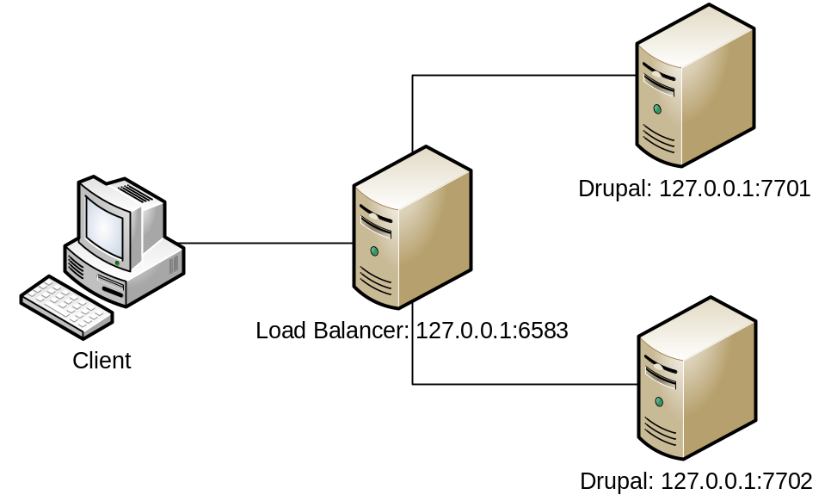

IMPORTANT: Note that the above is just an example. The actual server layout will be different (see section 7.1) Please also note that it uses local addresses so that this setup can be (and has been) tested on a local environment.

This kind of a setup is called a reverse proxy. We will use Apache Server mod_proxy module for the proxy setup and mod_proxy_balancer module for the load balancer setup.

For this we will first need to load the mod_proxy, mod_proxy_balancer and mod_proxy_http modules in the Load Balancer’s Apache Server httpd.conf.

LoadModule proxy_module modules/mod_proxy.so
LoadModule proxy_balancer_module modules/mod_proxy_balancer.so
LoadModule proxy_http_module modules/mod_proxy_http.so

The configuration for the balancer will be the following:
<Proxy balancer://mycluster/>
BalancerMember http://127.0.0.1:7701 loadfactor=1
BalancerMember http://127.0.0.1:7702 loadfactor=1
</Proxy>

The name of the balancer is balancer://mycluster/. The load between the target machines will be shared in the ratio 1:1 i.e. every alternate request will be handled by one target machine. There are other sharing algorithms but this is one suffices for now.

The configuration for the proxy will be as follows:
ProxyPass / balancer://mycluster/
ProxyPassReverse / balancer://mycluster/

Here, the first line states that all incoming requests to this server should be routed to one of the balancer servers. So a request to http://127.0.0.1:6583/abcd/xyz will be mapped to http://127.0.0.1:7701/abcd/xyz or http://127.0.0.1:7702/abcd/xyz based on the load balancer state.

The second line states that if the response header contains URLs which are relative to the target machine then they should be converted back to load balancer based URL. So for example in case of an HTTP redirect we can have the following header:
HTTP/1.1 302 Found
Location: http://127.0.0.1:7701/abcd/xyz/
The ProxyPassReverse will convert the above to
HTTP/1.1 302 Found
Location: http://127.0.0.1:6583/abcd/xyz/

Fixing the HTML links
The above configuration will effectively convert request and response headers URLs from the load balancer to the target machines (and vice versa). But it will not be able to convert HTML links in the served html.
So the following links
- <a href="somefile.html">
- <a href="/somefile.html">
- <a href="http://127.0.0.1:7701/somefile.html">
will all resolved relative to the target machine. This will result in “host not found” errors because the client browser does not know of the existence of the target machines.

For this will use the Apache mod_proxy_html module to convert the links to the proper URL.
The module needs to be declared and enabled. This is done as follows:
LoadFile modules/mod_proxy_html/libxml2.so
LoadModule proxy_html_module modules/mod_proxy_html/mod_proxy_html.so
LoadModule xml2enc_module modules/mod_proxy_html/mod_xml2enc.so

xml2EncDefault UTF-8
ProxyHTMLEnable On

#Uncomment the following for debugging
#ProxyHTMLLogVerbose On
#LogLevel Info

The module then needs to be told about the html attributes that it should attempt to convert. This is done as follows
ProxyHTMLLinks a href
ProxyHTMLLinks link href
ProxyHTMLLinks img src
ProxyHTMLLinks form action
ProxyHTMLLinks script src

The module then needs to be told the mapping of the source url format to the target url format
ProxyHTMLURLMap http://127.0.0.1:7701/ /
ProxyHTMLURLMap http://127.0.0.1:7702/ /
ProxyHTMLURLMap http://127.0.0.1:6583/ /
ProxyHTMLURLMap / http://127.0.0.1:6583/
Here the first 3 lines convert any absolute URL in the html into a relative url. The last line is the most important and it will convert any relative URLs to absolute URL where the url is of the load balancer.
The end result is that in the response HTML, all links will be absolute URLs pointing to the load balancer.

Designer has tested the above setup to be correct (albeit on Windows). The httpd.conf for the load balancer is provided in test_files folder.

Session maintenance
Drupal uses the database to store the session data. So if two Drupal installations are sharing the same database, then effectively they are sharing the same sessions if for the same user, they generate the same session_name (session cookie key) and session_id (session cookie value).

By default each application generates the same session_id but a different session_name. This is because the session_name generation is based on the application’s host name and port number. Since each individual machine in the cluster has a unique host/port, each machine ends up with a different session_name. We can observe this in the drupal_settings_initialize method. The last line is:
session_name($prefix . substr(hash('sha256', $session_name), 0, 32));
The $session_name is initialized as:
list( , $session_name) = explode('://', $base_url, 2);

Instead of the $session_name being initialized from the base_url, we can simply pick it up from configuration or can even hard-code to any arbitrary string. The condition being that it MUST be the same for all installations of Drupal the cluster servers.

Once this is done, we can login in one Drupal server (say 127.0.0.1:7701) and can then refresh the home page in the other Drupal server (127.0.0.1:7702) and we can observe that the user is logged-in in the second server as well. (This has been tested by architect)

Forum Functionality
Drupal provides an out of box Forum module. It only needs to be enabled. The enabling process is easy and is described here.
Drupal provides the ability to add forums, organize forums hierarchically, define forum containers for grouping forums, topics per page, default order, forum permissions etc.

After this we can go to the <drupal_root>/drupal7/forum URL and we can see all available forums.

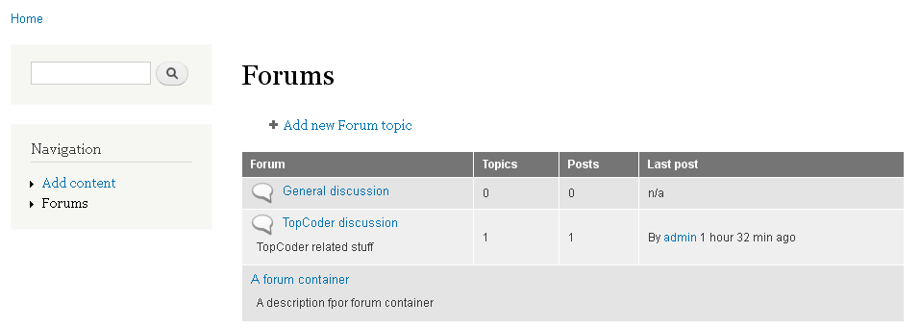

We can then click on one of the forums and can view forum topics there.
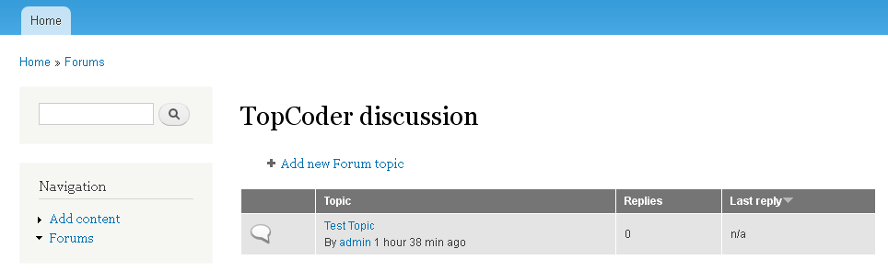

Forum topics can be added or edited. Comments are also enabled by default on each topic.

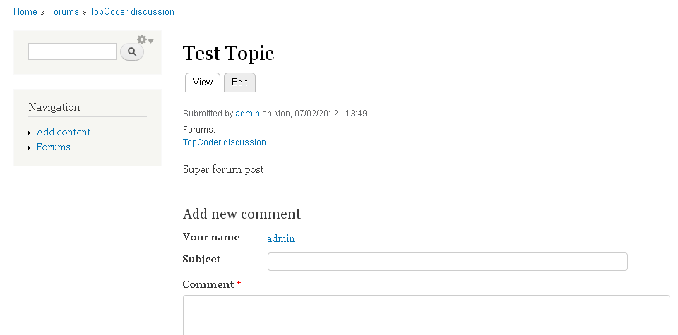

Drupal provides a Blogs module out of the box. It is described in fair detail on this page. The blog page will be available at <drupal_root>/drupal7/blog

We also need the ability to show a page with user posts in descending order of time. The Drupal home page already does this for us, and we can just include this page wherever required.

Drupal also supports tagging out of the box. In fact it has a very powerful module called ‘Taxonomy’ which allows to defined vocabularies with terms. The terms can be hierarchically related. Free-form tagging is supported. Tags can be added either by selecting from a checkbox list or even from an autocomplete textbox.
To enable tagging on any content type (say blog post), we need to go to Administration → Structure → Content Type → <Content Type> → Edit Fields and then add a field of type Term Reference. Then the auto-complete tag input box appears on each blog post form.

Content Management System
Drupal provides many ways of content management from the admin interface:

Articles, Basic Pages, Blog entries, Forum Topics can be managed from the Content menu for the admin.
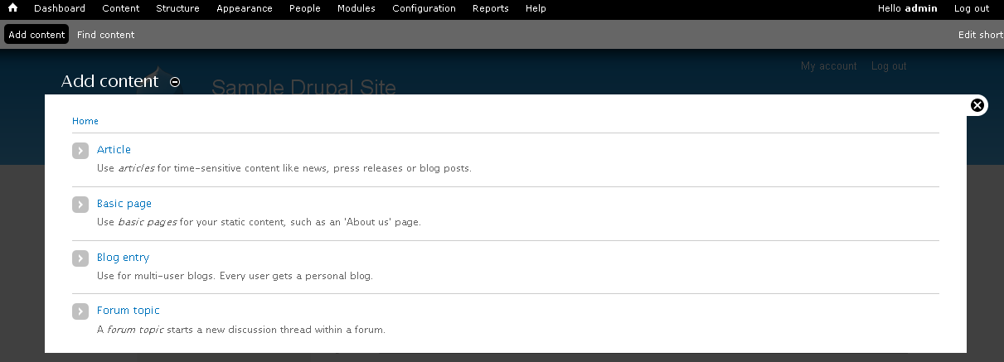

Configuration for the media files like images, documents, videos can be managed from the Configuration tab. Drupal however does not provide any Windows Explorer like interface for managing files.

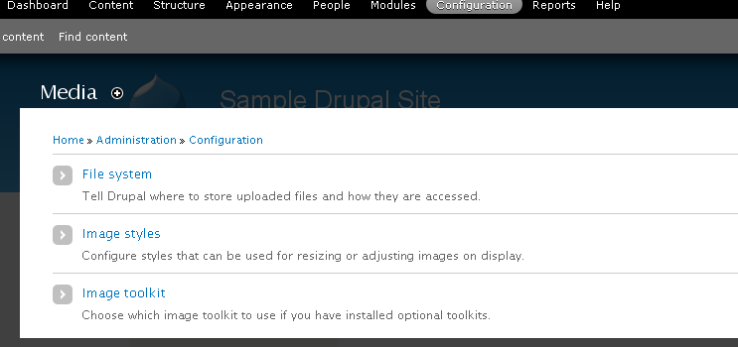

The user upload files location can be managed from the Administration → Configuration → File System as shown below:
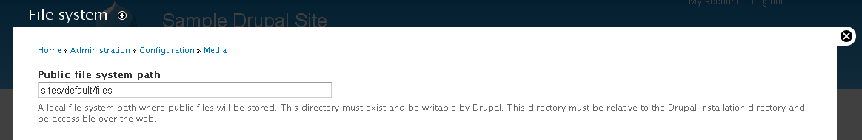

Style templates can be managed Administration → Appearance.

Personalization
For personalization, we need the user profile and user preferences features. The User Profile page already exists in Drupal and can be accessed at <drupal-root>/user. While editing, it allows a limited number of preferences like User Name, Email, Password, Picture and Time zone. If more preferences are needed, they can be defined and added to this page.

Please note that users cannot change the layout of their page. However, note that administrator can change the layout of the pages somewhat. A Drupal page layout is defined by modules laid out at predefined positions. These positions can be changed from Adminsitration → Structure menu.

Leaderboard Test Component and Web Service
The component will be developed as a Drupal module. It will be called leaderboard. Components are placed in the <Drupal-root>/sites/all/modules/<module_name> folder.

It will use Drupal PAC architecture. Please see the Leaderboard Class Diagram.

The leaderboard.module is the entry point for the component. It is a plain PHP file. Note that it does not end with php tag.

The entry point will not be object-oriented; instead it will just be plain PHP class. This is because Drupal expects custom code to be implemented via hooks. It searches for these hooks in the <module_name>.module file, and if these hooks are placed in a class, Drupal will not be able to locate these hooks.
Apart from the entry point file, other custom code can be object-oriented, such as the LeaderboardAbstraction in our module.

It will have the hook_menu implementation called leaderboard_menu which will register paths to which the module will respond. The method shown below first registers the JavaScript for the module, then it registers 2 paths:
- <drupal-root>/leaderboard/view_leaderboard: The path which shows the leaderboard page
- <drupal-root>/leaderboard/get_leaderboard_json: The path which will return the leaderboard json

function leaderboard_menu() {

drupal_add_js(drupal_get_path('module', 'leaderboard') .'/leaderboard.js');

$items = array();

$items['leaderboard/view_leaderboard'] = array(
'title' => 'Leaderboard',
'page callback' => 'view_leaderboard',
'access arguments' => array('access content'),
'type' => MENU_CALLBACK,
);

$items['leaderboard/get_leaderboard_json'] = array(
'page callback' => 'get_leaderboard_json',
'access arguments' => array('access content'),
'type' => MENU_CALLBACK,
);

return $items;
}

The view_leaderboard method can be seen as the controller for the page which shows the leaderboard. It performs the following logic:
- Call the LeaderboardAbstraction class and get the leaderboard data
- From the leaderboard data, create the rows and headers for the Leaderboard table
- Call theme method with ‘table’ parameter with the rows and header data. This will write an HTML table to the output.

function view_leaderboard() {
$abstraction = new LeaderboardAbstraction;
$leaderboardItems = $abstraction->getLeaderboard();

$header = array('Player', 'Game', 'Score');
$rows = array();
foreach ($leaderboardItems as $item) {
$rows[] = array($item->player, $item->game, $item->score);
}

return theme('table', array(
'header' => $header,
'rows' => $rows,
'attributes' => array ('id' => 'leaderboardTable')
));
}

The get_leaderboard_json method can be seen as the controller which returns the leaderboard data in json. It performs the following logic:
- Call the LeaderboardAbstraction class and get the leaderboard data
- Encode it as JSON and write it to the HTTP response

function get_leaderboard_json() {
$abstraction = new LeaderboardAbstraction;
$leaderboardItems = $abstraction->getLeaderboard();

return drupal_json_output($leaderboardItems);
}

The leaderboard data will be stored in database. There will simply be table which holds 3 columns {player, game, score}. The LeaderboardAbstraction.getLeaderboard simply gets all the LeaderboardItem records from the database. It will use the Database Persistence API (see section 7.4). A basic example is shown below:

$query = db_select('leaderboard', 'l')
->fields ('l', array (
'game',
'player',
'score',
));

$results = $query->execute();

We will also need to write a cron job which will update the leaderboard table with some sample data at a configurable interval. The assembler can use ultimate_cron module for setting up the cron job.

There will not be any dedicated view for the leaderboard component. The view will be generated by call to the Drupal theme method as shown above. Note: we can wrap the theme method call in a class but in this case it is just redundant code.

However there will be JavaScript which will be used to make AJAX requests to get the leaderboard json and bind it to the view. It is as follows:

(function ($) {

Drupal.behaviors.leaderboardModule = {
attach: function (context, settings) {
$.get('get_leaderboard_json', null, show_leaderboard);
}
};

function show_leaderboard(response) {
//Use the response to show the leaderboard
//Response must be added to HTML table with id = leaderboardTable
}

})(jQuery);

The code uses jQuery to make an AJAX call to the leaderboard/get_leaderboard_json path to get the leaderboard data. The show_leaderboard method is called when the response is received. It will write the retrieved leaderboard array to the HTML table with id = leaderboardTable.

We also need to make one change to the script above. The AJAX call should be timed ajax call which should run repeatedly at a configurable period. This can be done simply by using JavaScript’s setInterval method.

var ajax_call = function() {
//your jQuery ajax code
};
setInterval(ajax_call, interval_in_milli_seconds);

A sample leaderboard module is provided in the test_files folder. The output of the sample code is:
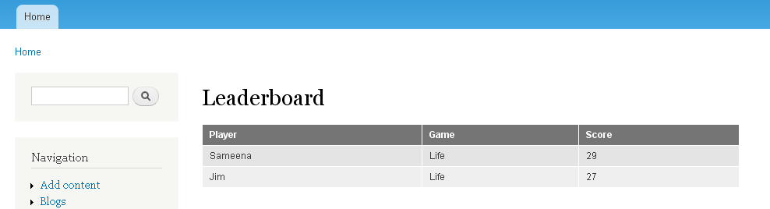

Memcached
Memcached will be used to cache common database query results and thus improve performance.
We will use Memcache API and Integration Drupal module. It provides an API over memcached and also provides an administrative interface for managing the memcached instances. The detailed installation instructions are available at http://drupal.org/node/1131468.

Initially we will use the simplest configuration for memcached. There will be only one memcached instance running per Drupal server. We should go for a clustered setup of memcached only if the present setup is too slow.

Note: We will have to write our code (in case of custom code) or modify the code (in case of Drupal code) in such a way so as to use caching programmatically. Memcached caching is not something we can achieve just by configuration. The API to add/update/delete data to/from cache is provided by the dmemcache file of the above mentioned module.

Security

Authentication and Authorization
Authentication is provided in Drupal with the help of the user_authenticate method of the user module.
Authorization is provided in Drupal both in form of user roles and permissions. Their administrative aspects are described in detail here.
In code, access control is done using the ‘access arguments’ key of a path definition. Typically (and as shown in section 5.6), the value is array('access content') , which means that the user must have access to view the content of the given path. More details are here.

Possible SSO usage
The setup for using SSO will very much depend on the provider of the SSO.
If the SSO provider is another Drupal website, then we can use Services SSO client module.
If the SSO provider is CAS, then we can use the Drupal CAS module for SSO.
In case of a custom provider, we will need to write a custom module.

Audit
There are no auditing privacy issues.

Data Privacy
There are no data privacy issues.

Data Integrity
There are no data integrity issues.

Deployment and Development Concerns

Logical Deployment
The system architecture diagram is as follows:

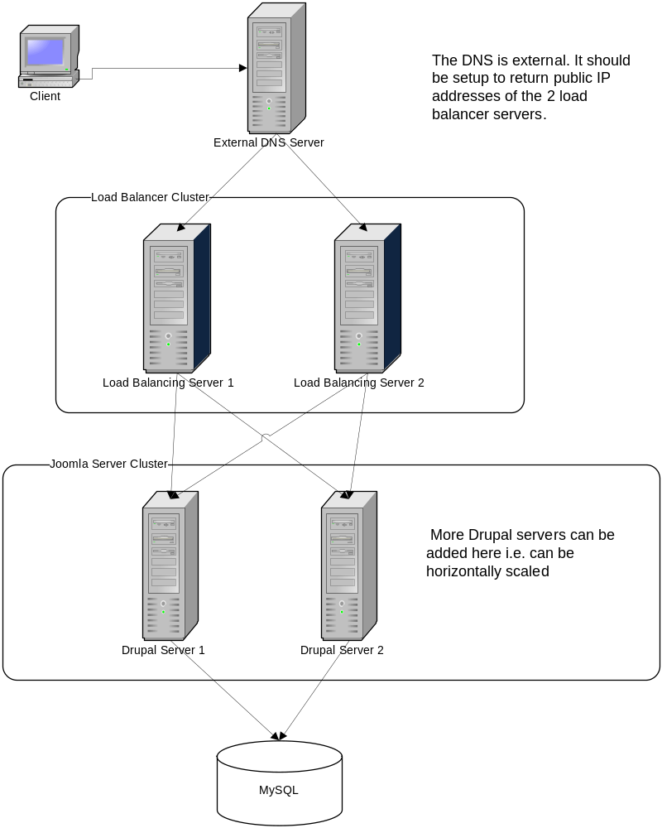
- The DNS server is external. It should be setup to return the public IP addresses of the 2 load balancer servers.
- The presence of 2 load balancer servers instead of just 1 will prevent the load balancing server from becoming a single point of failure.
- Each load balancer will act as a gateway to each of the Drupal servers. Initially, only 2 should be enough, although more can be added later.
- Each Drupal server must run the same codebase.
- Each load balancer server will run an Apache HTTP Server in load balancing mode.
- Each Drupal server will run the XAMPP for Linux stack along with the Drupal installation.
- There will be a single MySQL server which will serve all Drupal servers.
- There will be one memcached instance on each Drupal server.

Amazon specific information
The strategy used in the CSSTEM setup is that there is a single EBS attached to one of the servers. This server then exposes an NFS to the other servers. Although this means that there is just one file system that all servers can access, the big drawback is that this NFS server becomes a single point of failure. If it fails, all other servers cannot access the file system.

However this setup seems unavoidable as we need a common place to store user uploads. There seems to be no way to configure Drupal to store the user uploads in the database (other than editing the core Drupal code).

The NFS will be located on an EBS attached to an EC2 instance. The machine hosting the database is a good candidate, as it is already a central point of access for all the Drupal servers. We can also use a dedicated machine for hosting the NFS. However hosting the NFS on one of the Drupal machines is not a good option.

This page gives a step by step description of how to setup an NFS for storing user uploads for Drupal.

We should use Amazon RDS for MySQL to achieve scalability (although not redundancy) to the MySQL server setup.

Physical Deployment

User Metrics Requirements
- Not known but architecture is horizontally scalable to accommodate the requirements.

Page Performance Requirements (assumed)
- The application will be available 24x7. Up-time will be 99.5%.

Operating System(s)
- CentOS 6

Software
- PHP 5.3.8

Database
- MySQL 5.5.16

Browsers
- Latest versions of all browsers

Application Server
- Apache HTTP Server 2.2.21

Frameworks/Tools
- XAMPP 1.7.7 for Linux: http://www.apachefriends.org/en/xampp-linux.html
- PHP 5.3.8: (part of XAMPP)
- Drupal 7.14: http://drupal.org/download/
- jQuery 1.7: (part of Drupal)
- Amazon EC2, EBS, RDS
- Memcached: http://memcached.org

User Interface Implementation
Drupal provides its own user interface. For custom development using PAC, the view will typically simply be created by calling the theme method provided by Drupal. In more complicated cases, HTML templates with PHP code thrown-in will be used.

Persistence
The data access will be done using Drupal’s powerful Database API with its Hibernate-like query language as demonstrated here. Data reading is typically done using db_query method and data writing is typically done using db_insert, db_update and db_delete methods.

Concurrency and Transaction Management
The db_transaction method returns a transaction object. The transaction is already started by this method. The rollback method can be used to rollback. Once the transaction object goes out of scope, it gets automatically committed.

Configuration
Most application configuration is stored in the settings.php (in <drupal-root>/sites/default folder).
Some application configuration is stored in the database. This is the application configuration which is editable from the administrative user interface.

Logging
The application will perform automatic logging of errors, exceptions, warnings, debug messages using the watchdog method. The logging level is defined by the $severity parameter.

Internationalization
There are no internationalization requirements.

Validation
Business validation if required should be performed in the PAC Controller.

Exceptions
Drupal provides many exception classes which can be thrown like any PHP exception. All uncaught exceptions are automatically logged by the _drupal_exception_handler method

